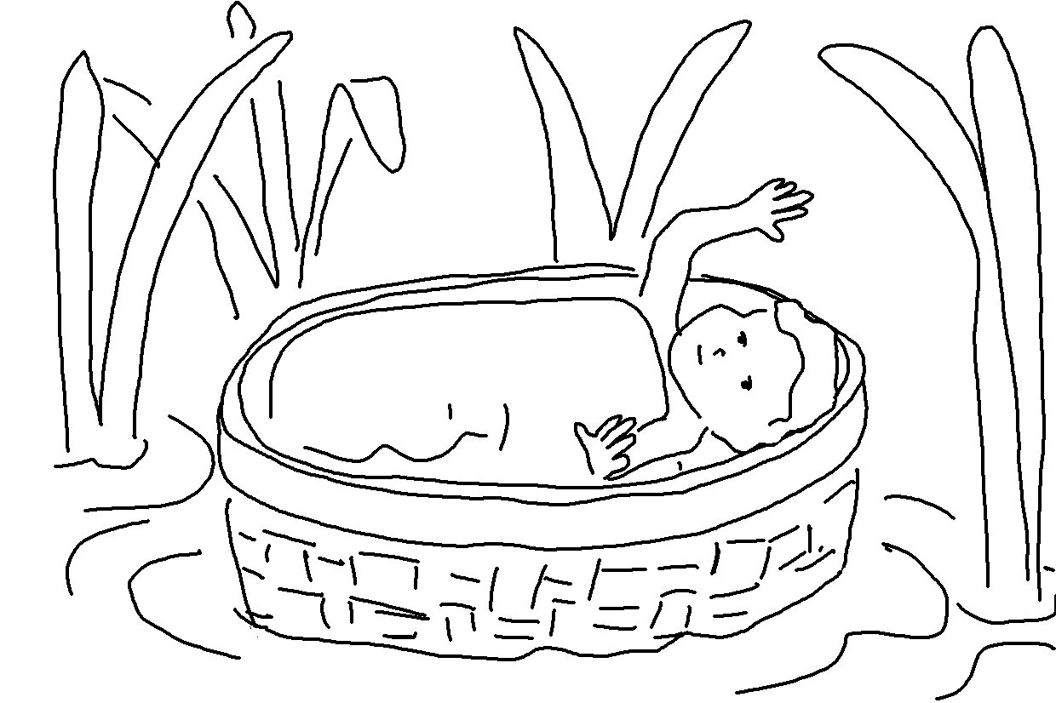
The _ _ _ _ is for me, so I will have no _ _ _ _. Psalms 118:6_{NLT}

